Table of Contents
Self Balancing Car 3
Overview 3
Component Selection 4
Design Iterations 4
Version 1 4
Version 2 5
Automated Medicine Dispenser 6
Overview 6
Component Selection 7
Functionality 7
Design Considerations 7
Points of Improvement 8
Lifter Robot – Fly Away 9
Overview 9
Design Iterations 10
Version 1: Smail Cam & Extension Springs 10
Version 2: Crank-Rocker Linkage 11
Material Selection 11
Points of Improvement 12
Custom STM32 PCB 13
Overview 13
Schematic 14
Microcontroller (STM32F411CEU6) 14
USB Connector and LDO Regulator (+5V to +3V3) 16
Inertial Measurement Unit (MPU-6050) 17
Layout 18
48V – 12V Buck Converter 19
Overview 19
Schematic 20
Layout 22
Input Capacitors & Feedback 22
General Layout Conventions 22
9V – 3.3V LDO 24
Overview 24
Schematic 24
Layout 25

Self Balancing Car

Overview
During the Waterloo Senior Engineering Competition, my team built a beam-balancing robot using an Arduino Uno, L298N motor driver, and MPU6050 gyroscope. Due to limited programming experience at the time, our implementation relied heavily on empirical tuning rather than automated control. This inspired a teammate and me to design our own self-balancing robot.
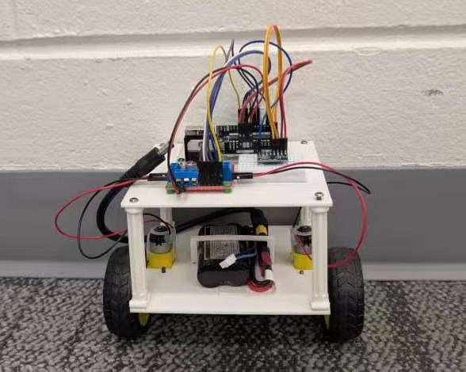
Video Link

Component Selection
Arduino Uno: Central microcontroller, simple to use and has an extensive ecosystem.
L298N Motor Driver: Allows bi-directional control, simple to wire and implement.
MPU6050 Gyroscope & Accelerometer: Measures vehicle tilt and orientation in real time to feed the balancing algorithm.
DC Gear Motors (×2): Easily wired and very accessible.
7.4V Li-ion Battery: Rechargeable and provided sufficient power to the entire system.
As we were building foundational skills, component selection prioritized well-documented hardware with reliable community resources to ensure smooth troubleshooting during system integration.

Design Iterations

Version 1
To maximize stability, the initial structure aimed for a low center of mass, placing heavy elements like the battery near the base while keeping processing electronics on top. The base used perpendicular snap-fit beams to lock the battery in place, while four 3D-printed columns supported the top tier as a fun aesthetic challenge.
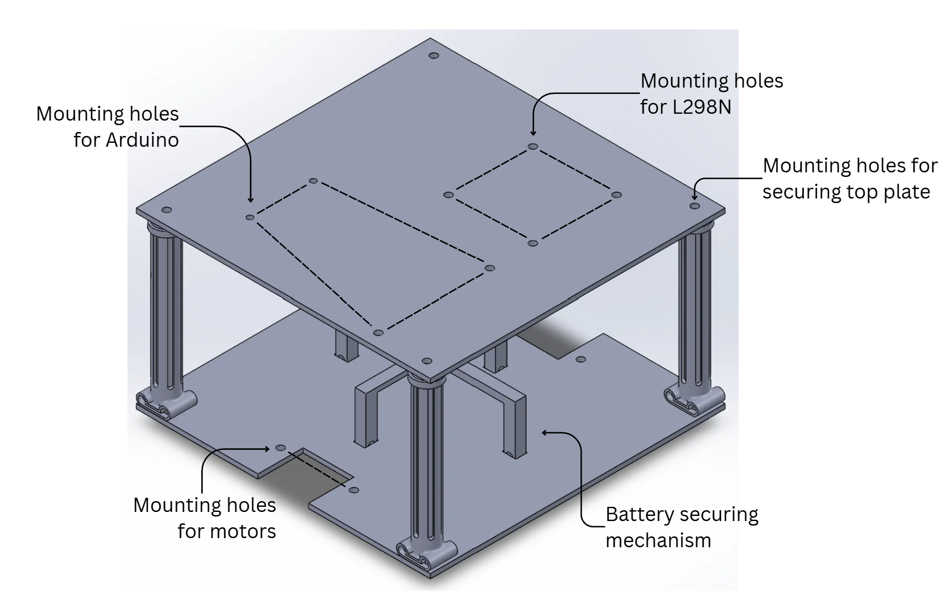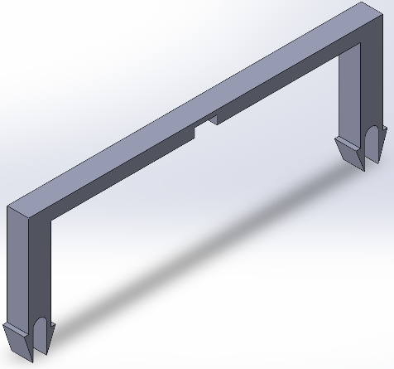
I designed the battery housing, which included a horizontal beam with a central alignment slot for the other vertical beam to pass through. To address stress concentrations during assembly, I added fillets to the slot joints and chamfered the baseplate mounting holes for smoother component insertion.

Version 2
Hands-on testing highlighted key areas for improvement, leading to a second-generation design focused on structural stability and practical assembly
Aspect Ratio & Stability: The original square layout had a narrow stability margin that caused rapid tipping. The new version is more rectangular, which allows for more reaction time, increasing the capability to self-right.
Optimal Gyro Placement: The revised three-tier structure places the MPU6050 along the center-of-mass axis at the top, delivering cleaner sensor data to the controller than off-centre mounting.
Reliable Mounting: The 3D-printed snap locks for the battery were prone to deformation and snapping over time. Replacing them with zip-tie friction mounts simplified tolerances while providing a secure, repeatable hold.
Standardized Hardware: Fasteners were upgraded from printed pins to off-the-shelf screws and nuts, eliminating printing tolerance constraints.
Side Covers: Extra precautions in case the electronics fall out.
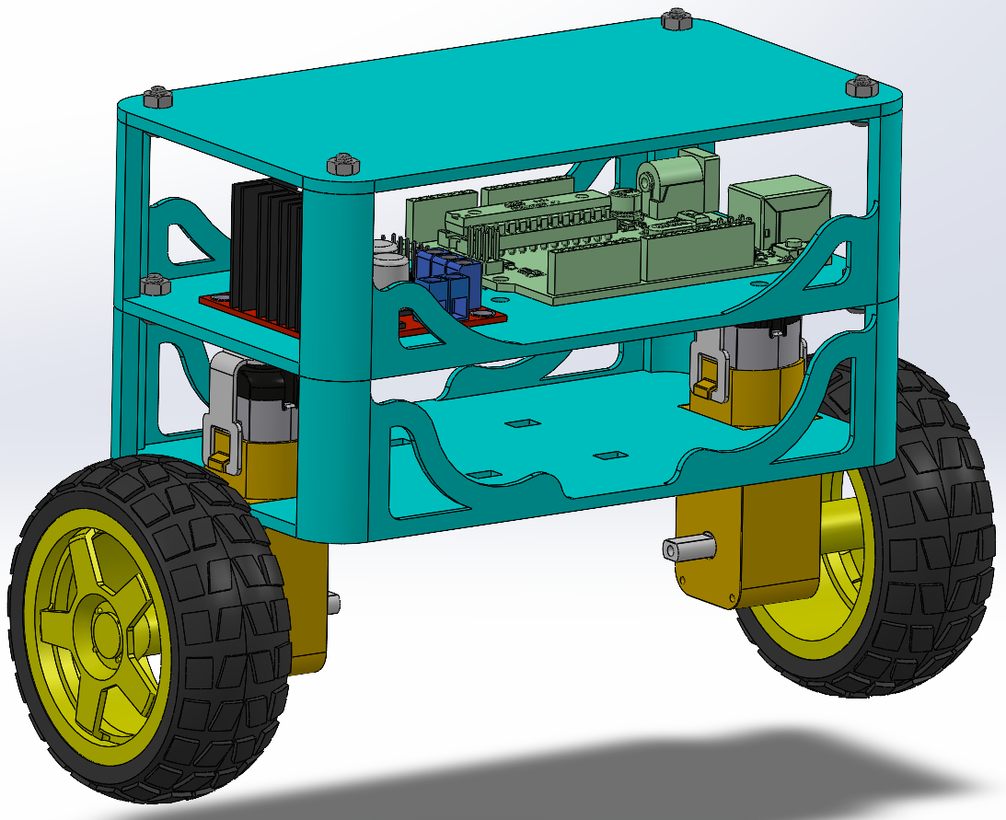

Automated Medicine Dispenser

Overview
Many people take daily medications, including vitamins and prescriptions, yet it is easy to forget or miss doses. To address this, my team designed an automated medicine dispenser using VEX components that alerts users when it is time to take their medication and dispenses it automatically.
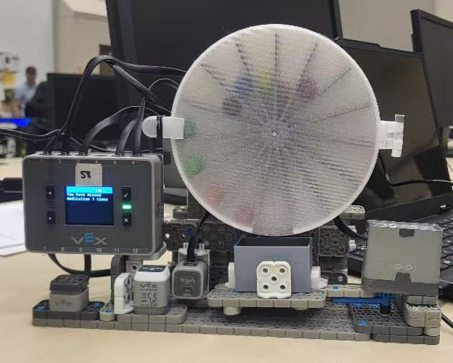
Video Link

Component Selection
VEX Brain: Controls sensors, motors, timing logic, and screen output.
Bumper Sensor: Increments time parameters and allows the user to log a skipped dose.
Touch Sensor: Confirms scheduled alarm times and dispenses medication once pressed.
Distance Sensor: Detects user presence to ensure they have taken their medication before auto-retracting.
Stepper Motors (×3): Drive the inner rotor, rotate the dispensing drawer, and tilt the dispenser box for refills.

Functionality
Alarm System: Alerts the user with visual and audio cues at the scheduled medication time.
Dispensing Logic: Pressing the touch sensor dispenses pills into the tray; the bumper sensor manually logs a skipped dose.
Automated Drawer: Extends outward during dispensing and automatically retracts after the user leaves.
Compliance Tracking: Records, tallies, and displays taken vs. missed doses directly on the screen display.
Refill Alert Mechanism: Tilts the pill box frame when medication runs empty, signaling the user to reload.
* To view the full source code implementation, check out my repository on GitHub.

Design Considerations
Inner Rotor: Designed with 15 individual compartments to hold up to 14 doses of medication. Dimensioned slightly smaller than the outer shell to guarantee smooth rotation without pill spilling.
Drawer Mechanism: Features a rounded, curved interior floor for easy pill retrieval and cleaning.
Enclosure Cover: Built-in magnet slots allow quick detaching for refilling; fine-tuned 3D printing settings were used to achieve a clear, translucent finish.
Sensor Placement: Touch and bumper sensors are mounted directly under the VEX Brain for convenient access, while the distance sensor faces outward from the drawer to monitor user’s distance.

Points of Improvement
Time Input Restrictions: Interface code does not currently allow users to edit or re-enter reminder times if an error is made during setup.
Sensor Multi-mapping: Mapping multiple functions to single sensors created mild usability confusion during user testing.
Drawer Motion Profile: The drawer extends and retracts along a radial arc rather than a linear track, which proved less intuitive.
Clear Optical Path: The distance sensor requires an unobstructed line-of-sight to correctly detect user departure and trigger drawer retraction.

Lifter Robot – Fly Away

Overview
Fly Away is one of WATBOTs’s (the University of Waterloo’s combat robotics team) 3lb robots, and it was both my starting project in the team and my co-op project.
In BotBrawl (Canada's robot fighting league), matches are judged on damage, control, and aggression. Fly Away was designed explicitly as a control bot. The core strategy for Fly Away is to gain control points by pinning opponents against walls with fork/wedge configuration or flipping them with a lifting mechanism.
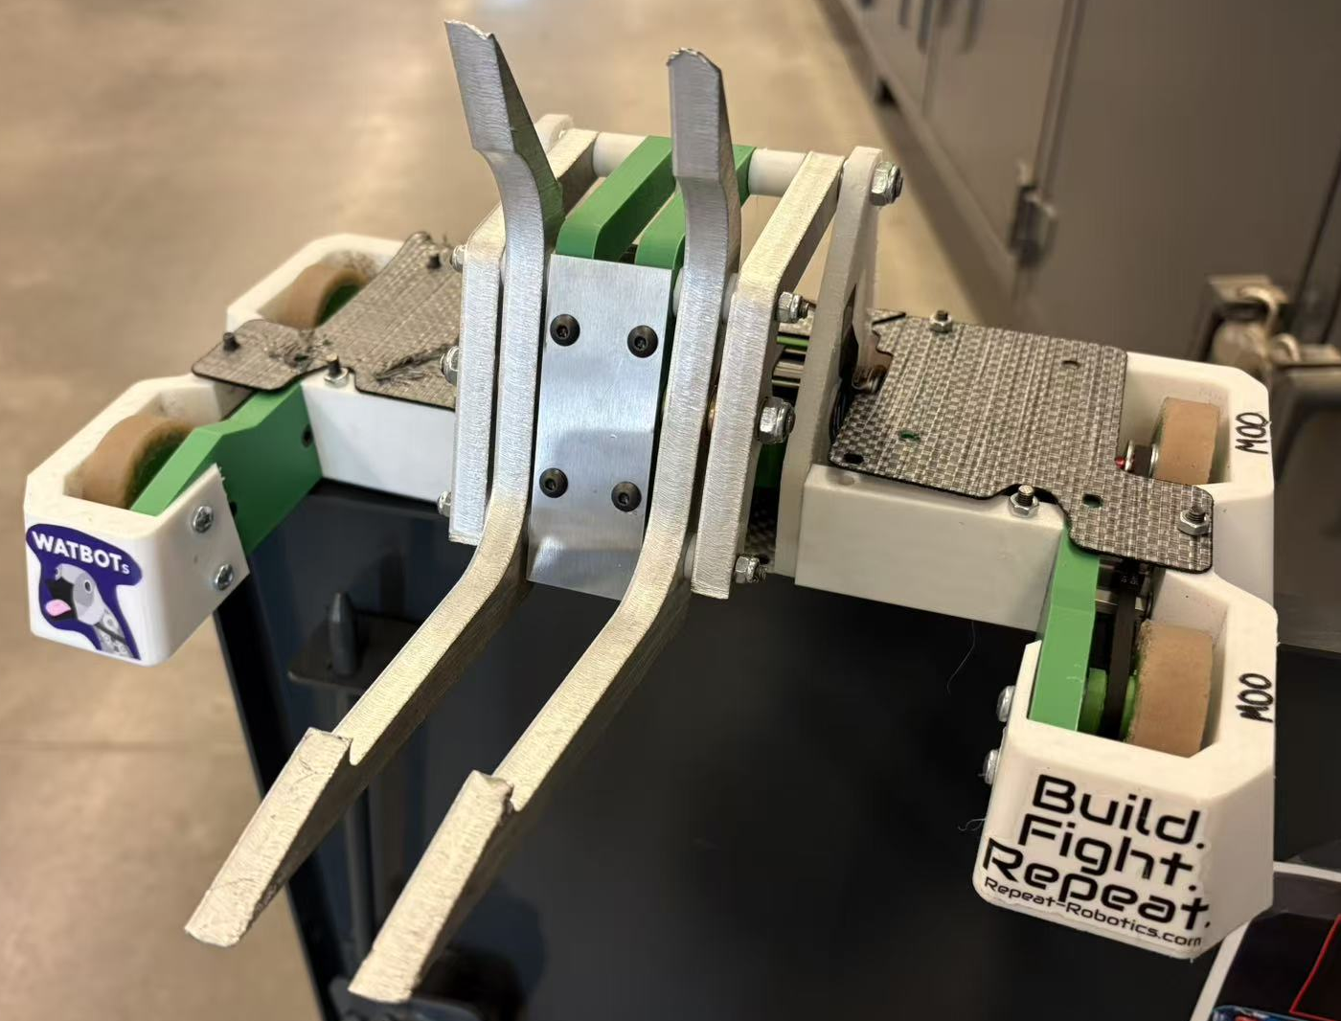
Fly Away Videos

Design Iterations

Version 1: Smail Cam & Extension Springs
The initial version attempted to store energy using a snail cam mechanism paired with heavy extension springs, aimed at launching opponents into the air.
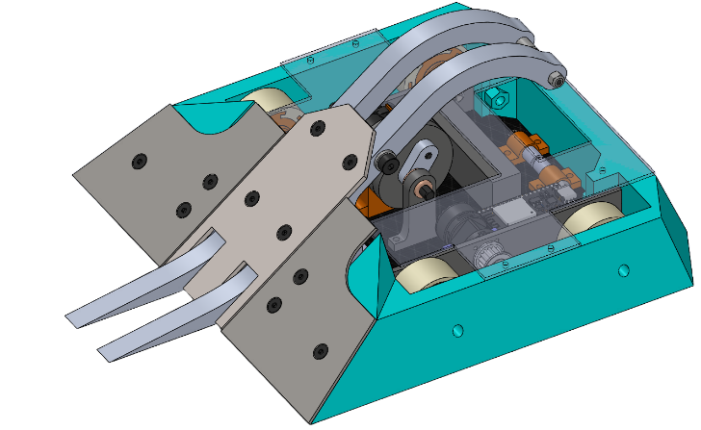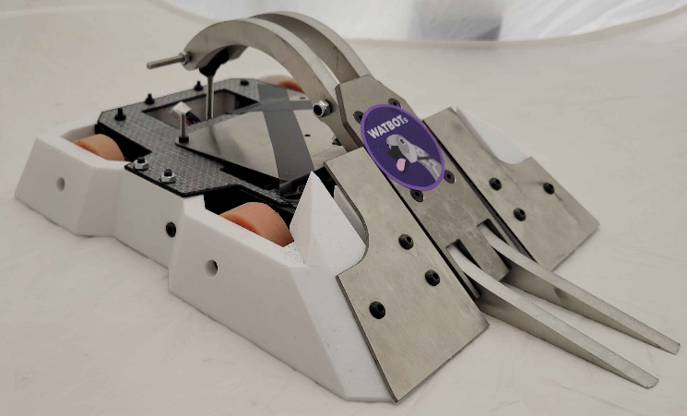
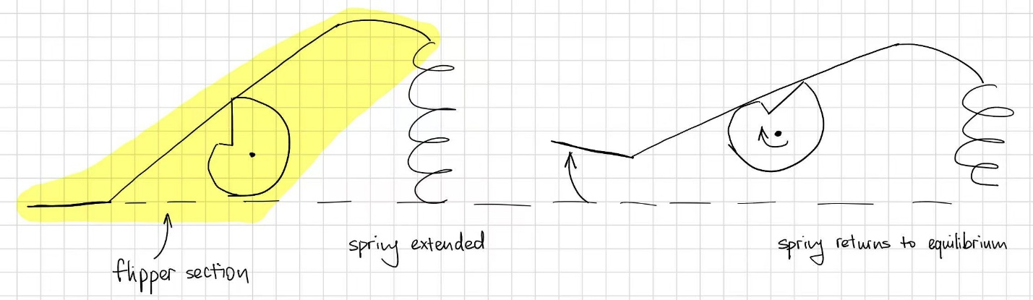
In the initial testing stage, a plastic model of the flipper was used with less stiff springs and a lighter load, which was misleading on how well the flipper would work once fully finished.
*See video reference
Mechanism failure: Material deformation and improper component placement caused the spring to pull the entire flipper structure upward rather than releasing kinetic energy through the arm.
Anime North 2026: Due to a tight 2-week manufacturing timeline, tolerance stack-up on the cam and over-stiff springs, the flipper system were removed and Fly Away became a wedge robot.

Version 2: Crank-Rocker Linkage
The design transitioned from a flipper to a crank-and-rocker four-bar linkage lifter. A linkage simulation software was used to tune arm ratios to maximize lifting height while keeping the flipper system a reasonable size.
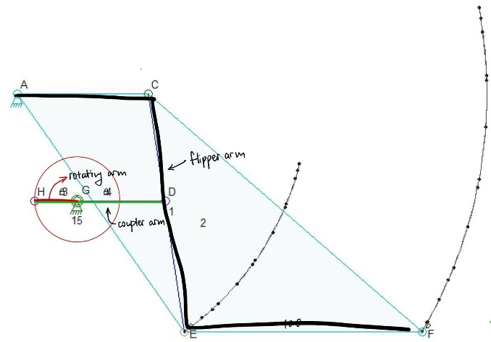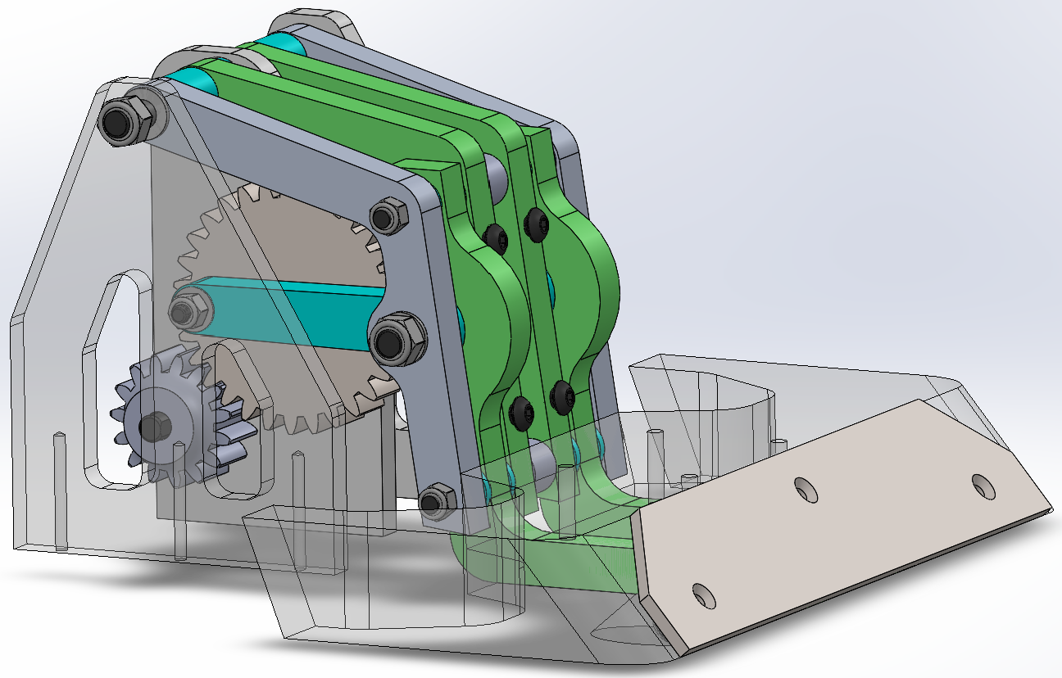
Modular Attachments: Implemented interchangeable front attachments – forks for vertical spinner opponents, and wedges for horizontal spinners to prevent weapon damage.
Gear Reductions: Driven by a dedicated high-torque gear motor mated with a 1:2 spur gear reduction to prevent parts from hitting each other internally.
Drive & Geometry: Shifted to rear-wheel drive with extended front caster wheels to prevent tipping forward when lifting opponents.

Material Selection
Materials were specifically chosen to balance weight constraints with impact resistance against high-speed spinning weapons:
Part Name | Material | Description
Outer Shell & Wedges | TPU | High impact absorption, flexibility, and crack resistance against weapon hits. Custamizable 3D print settings allowed for weight savings.
Bottom Plate | Carbon Fiber (1mm) | Provides extreme rigidity and structural strength at minimal weight.
Top Plate | Tegris (1.4 mm) | Lightweight, highly impact-resistant armor protecting top electronics.
Flipper Uprights | UHMW (1/4 inches) | Rigid, lightweight material supporting high-stress arm pivot points.
Inner Supports & Mounts | ABS / Super PLA+ | Dimensional stability and customizable 3D printed geometry.
Arms & Forks | Aluminum (3/8 inches) | High strength-to-weight ratio for primary load-bearing linkage arms.
Fork Plate | AISI 304 Stainless Steel (1mm) | Good strength to weight ratio, worked well in both design iterations.
Wedge Plate | Ti-6Al-4V Titanium (3mm) | Good strength-to-weight ratio to deflect low blades.

Points of Improvement
Competing at the BotBrawl Summer Classics validated the overall mechanical improvements, while exposing critical areas for future iteration:
Design for Assembly (DFA): Version 1 required a very specific teardown sequence. Version 2 eliminated unnecessary top plate and side chassis fasteners, and had an independently removable lifter system.
Wire Management: Planned wire routing paths ahead of time instead of blindly stuffing electronics into the robot to prevent loose solder joints/snapped wires during high impacts. Better wire management also allows for easier repairs between matches.
Identified Failure Modes: Lack of an inverted self-righting mechanism remains a vulnerability when being tossed around. Radio control should be implemented since it does not have latency issues, unlike Bluetooth control.

Custom STM32 PCB

Overview
I designed a custom STM32 development board by following a YouTube tutorial to build intuition for electrical design while strengthening my skills in Altium and becoming familiar with its features. This project also served as an introduction to the STM32 ecosystem, providing a starting point for learning embedded systems development.
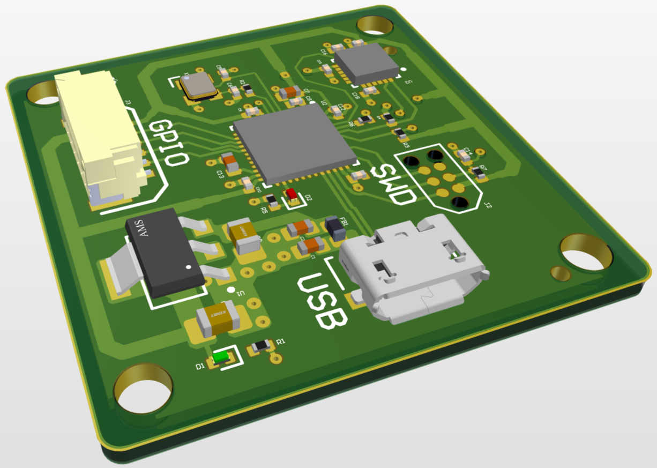

Schematic
All capacitors, resistors, LEDs, and crystals are SMD to match MCU speed, enable proper decoupling, and allow cleaner and smaller layout.

Microcontroller (STM32F411CEU6)
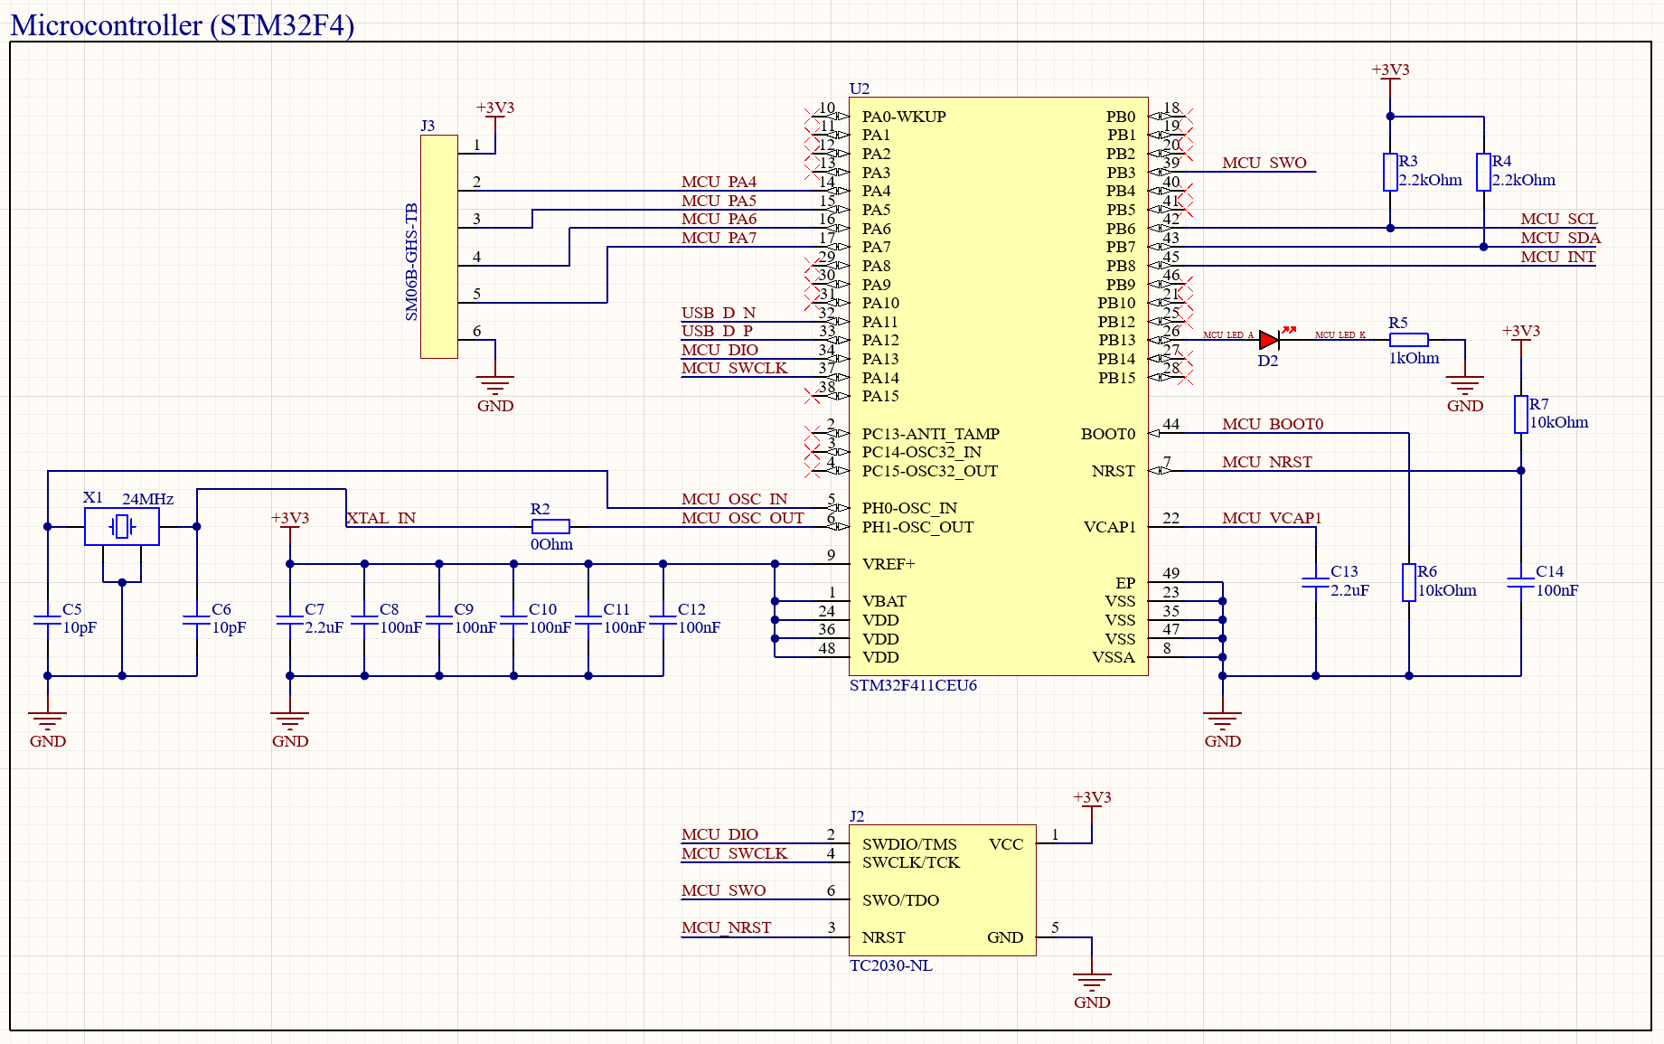
2.2uF Capacitor 0603 (C7, C13):
- C7: Bulk capacitor stabilizing 3.3 V supply against low-frequency transients.
- C13: Required capacitor for STM32 internal core voltage regulator stability.
10pF Capacitor 0402 (C5, C6): Crystal load capacitors ensuring stable oscillation and correct frequency.
100nF Capacitor 0402 (C8-C12, C14):
- C8-C12: Local decoupling capacitors suppressing high-frequency switching noise at VDD.
- C14: NRST (used to restart MCU or hold it in a restart state) line noise filtering and reset signal stabilization.

Red LED 0402 (D2): Visual indicator for firmware status and debugging.
Debugging Cable (J2): Provides SWD programming, debugging, reset, and power reference access.
Header Connector (J3): External peripheral connector supplying power, ground, and GPIO signals.
1kOhm Resistor 0402 (R5): Limits current through MCU status LED to safe levels.
0kOhm Resistor 0402 (R2): For oscillator debugging or trace impedance tuning.
2.2kOhm Resistor 0402 (R3-R4): I²C pull-up resistors defining logic-high levels on SDA and SCL.
- I²C (Inter-Integrated Circuit): communication protocol that uses 2 bi-directional lines SDA (Serial Data Line) and SCL (Serial Clock Line), one for transmitting data and one for clock signal to synchronize data transfer.
10kOhm Resistor 0402 (R6-R7):
- R6: Pull-down resistor keeping NRST low during power-up conditions.
- R7: BOOT0 pull-up selecting normal Flash boot mode.
24MHz Crystal (X1): Provides accurate external clock for STM32 system timing.
- Crystals, specifically quartz, are used in electronics through the piezoelectric effect. When pressure is applied to the crystal, it generates a tiny electrical voltage. Using this idea in reverse, a small piece of crystal is put into a crystal oscillator; when electricity passes through, the crystal vibrates at a precise and stable frequency. The circuit counts these vibrations to keep perfect time.

USB Connector and LDO Regulator (+5V to +3V3)
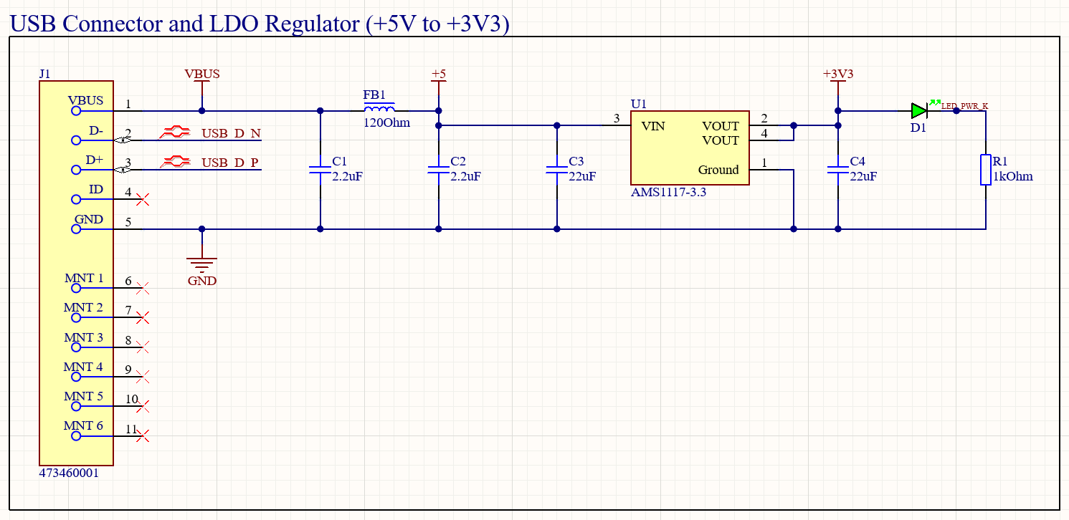
USB Connector (J1): Provides USB power, data signals, and ground from host device.
AMS1117 Voltage Regulator (U1): Linear regulator converting 5 USB supply to 3.3V.
2.2uF Capacitor 0603 (C1-C2):
- C1: Bulk capacitor smoothing USB VBUS voltage fluctuations.
- C2: Input decoupling capacitor improving regulator stability and noise rejection.
22uF Capacitor 0402 (C3-C4):
- C3: Additional bulk capacitance supporting regulator transient current demands.
- C4: Output capacitor ensuring AMS1117 stability and low output ripple.
Green LED 0402 (D1): Indicates presence of regulated 3.3 V power rail.
120Ohm Ferrite Bead 0603 (FB1): Filters high-frequency noise from USB VBUS before regulator input.
1kOhm Resistor 0402 (R1): Limits current through power LED to safe operating level.

Inertial Measurement Unit (MPU-6050)
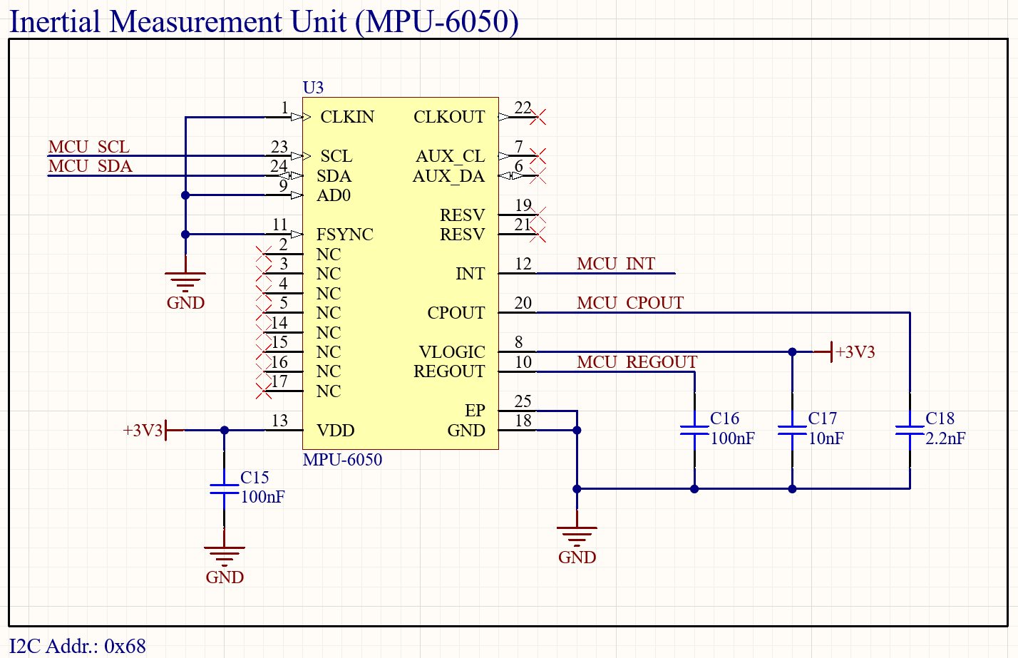
100nF Capacitor 0402 (C15-C16):
- C15: Filter noise and stabilize internal voltage regulator.
- C16: Decoupling capacitor.
10nF Capacitor 0402 (C17): Allow clean digital signaling.
2.2uF Capacitor 0603 (C18): Energy transfer element for charge pump.

Layout
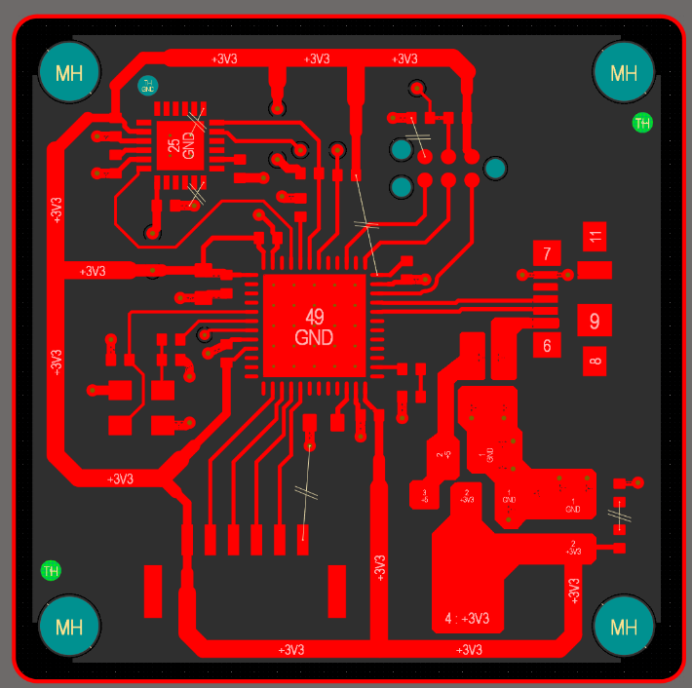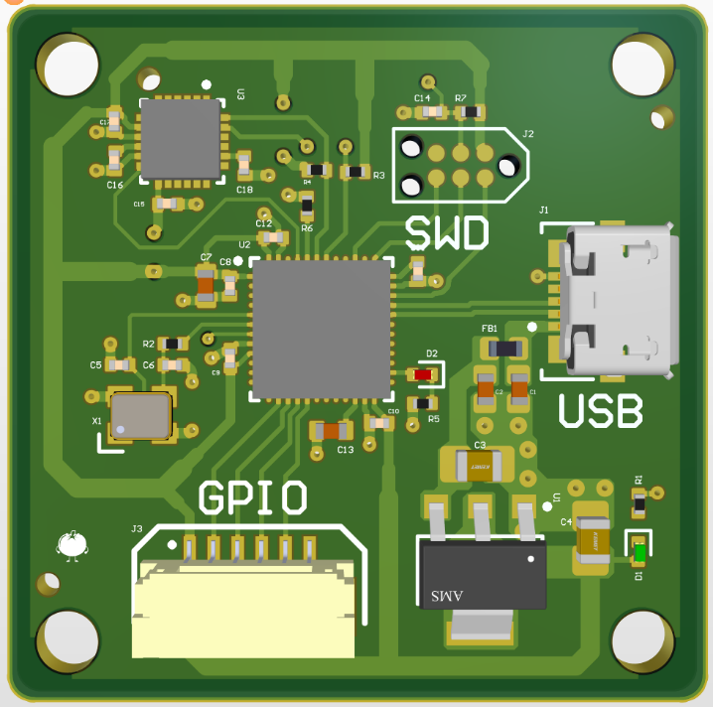

48V – 12V Buck Converter

Overview
Since I am still fairly new to PCB design and this is my first independent project, the description is formatted as a Q&A to document the questions I had while reviewing the datasheet, selecting components, and completing the layout.
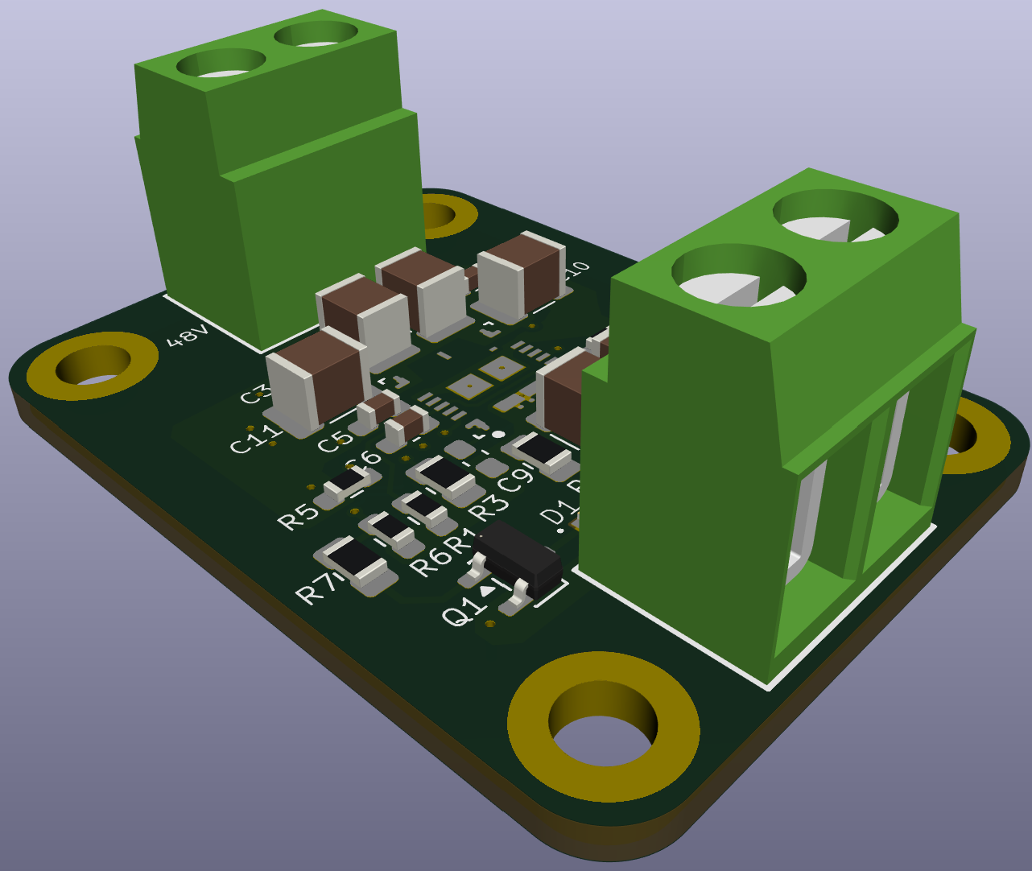

Schematic
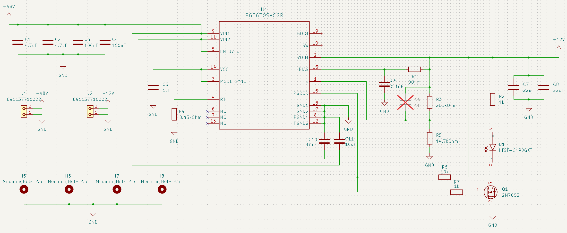
The TI TPSM65630 (P65630SVCGR) was selected because its operating parameters match the target input voltage range.
What is a low-impedance connection?
- A connection typically ranging from 2 to 600 Ω.
- It allows high current transfer with minimal power loss and voltage drop.
Why are there two VIN pins if they are tied together?
- Splitting current load (thermal management): Sharing the current across two pins reduces contact resistance and distributes heat evenly.
- Internal circuit separation (noise cancellation): Separates noise-heavy high-power switching transistors from sensitive analog control logic to prevent switching noise from interfering with feedback loops.
- Silicon layout and geometry: Optimizes internal die spacing and silicon trace routing.
- VIN1 and VIN2 are tied together externally and connected to an input capacitor array.
- C_IN (Bulk Capacitor): Serves as a local energy reservoir, supplying rapid current demands when internal switches turn on to prevent input voltage dips.
- C_HF (High-Frequency Decoupling Capacitor): Filters out fast, high-frequency voltage spikes that bulk capacitors cannot suppress due to parasitic inductance.

What capacitor types are best for high-power applications?
- Multilayer Ceramic Capacitors (MLCCs): Selected for their low Equivalent Series Resistance (ESR) and low Equivalent Series Inductance (ESL), enabling efficient noise filtering without power delivery bottlenecks.
- X7R/X7T Dielectrics: Maintain structural stability and capacitance across high temperature and high voltage ranges.
What is a precision enable pin (EN)?
- An input pin that enables or disables the IC at an exact, predictable voltage threshold (typically within 2% to 3% tolerance).
- EN is connected to VIN as specified in Table 5-1 (Pin Functions) of the datasheet.
If VCC originates from an internal LDO, why is it broken out to a pin, and why is the LDO needed?
- The internal LDO steps down high input voltages to a safe operating level for internal control circuits.
- The external pin allows decoupling to complete the required circuit loop (input, output, and ground reference) and stabilize internal supply rails.
Why use two 22 µF capacitors in parallel for COUT?
The datasheet specifies a minimum COUT of 15 µF. Ceramic capacitors experience capacitance loss under DC bias voltage, so two capacitors are placed in parallel to:
- Halve the Equivalent Series Inductance (ESL).
- Reduce DC bias capacitance degradation compared to using a single larger package.
- Improve thermal dissipation across multiple components.
The feedback resistor values (RFBT and RFBB) were determined using Table 7-2 in the datasheet.
How is the timing resistor (RT) value calculated?
- Target switching frequency (FSW): 1800 kHz (selected from Table 7-2).
- Calculation formula: $RT\text{ (k}Ω\text{)}=\frac{16.4}{FSW\text{ (MHz)}}-0.633$
- Calculated value: $8.4781\text{ k}Ω$; selected the closest standard resistor value ($8.45\text{ k}Ω$).
What is the difference between AUTO and FPWM modes on the MODE/SYNC pin?
- AUTO Mode: Reduces switching frequency at light loads to maximize power efficiency.
- FPWM Mode (Forced PWM): Maintains a fixed switching frequency regardless of load, delivering predictable output ripple and lower noise.
- Selected FPWM mode for EV applications to maintain deterministic signal behavior.
Resistor power ratings were selected with a 2x safety margin over expected power dissipation.
While the PGOOD pin typically interfaces with an external microcontroller, an onboard MOSFET-driven LED indicator circuit was added to provide visual status indication for standalone operation.

Layout

Input Capacitors & Feedback
- Input capacitors are placed symmetrically and as close as possible to the VIN pads, using direct copper pours on the 48V net to minimize loop impedance.
- The feedback resistor divider is placed directly adjacent to the IC feedback pin as recommended by the datasheet.

General Layout Conventions
- Implemented solid copper pours for power and ground planes to minimize resistance and inductance.
- Routed standard signal lines using trace widths between 0.2 mm and 0.3 mm.
If wider traces lower resistance and inductance, why not make all traces wide?
- Trace width is selected based on current capacity, allowable temperature rise, voltage drop, and impedance requirements.
- Extending copper pours to every trace introduces unnecessary parasitic capacitance, which negatively affects high-speed signal integrity.
- For power and ground planes, inter-plane parasitic capacitance acts as a distributed high-frequency decoupling capacitor that stabilizes supply rails. However, on signal traces, excess capacitance forces signal drivers to charge and discharge larger parasitic loads, slowing edge transitions and degrading signal quality.
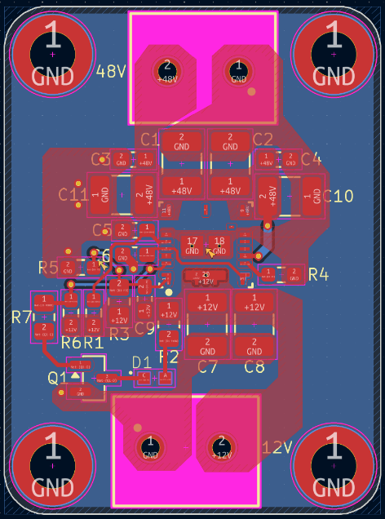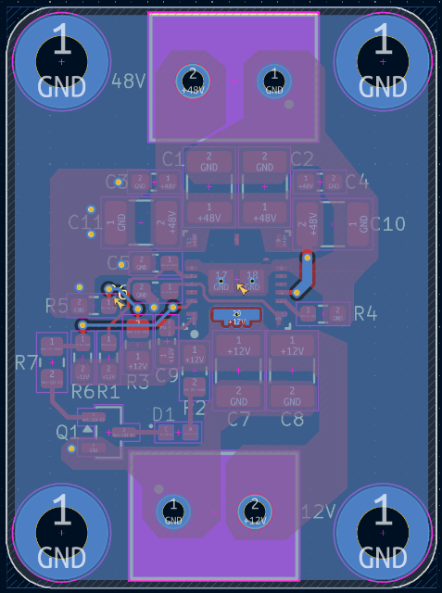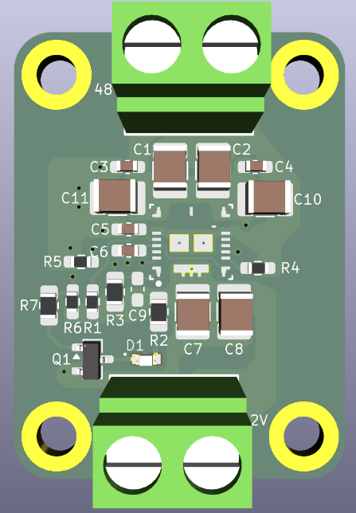

9V – 3.3V LDO

Overview
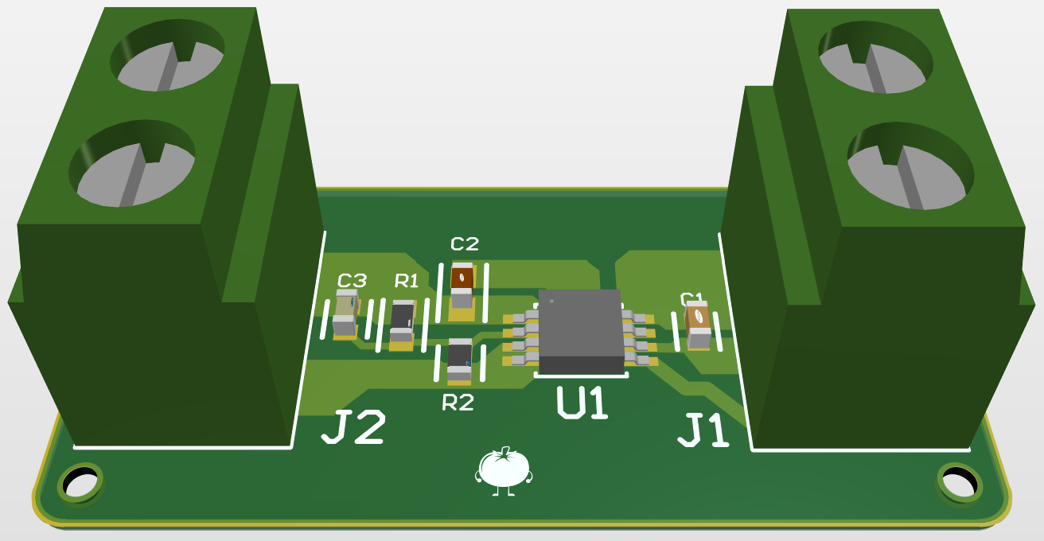
This Low Dropout (LDO) regulator module was created as an onboarding design project for my school's robotics team. Built around the TLV76701 adjustable linear regulator, the board steps down an unregulated 9V input down to a stable 3.3V output to safely power low-voltage logic components and microcontrollers.

Schematic
All component values and ratings were selected strictly according to datasheet recommendations to ensure operating stability:
- Capacitors: Multi-Layer Ceramic Capacitors (MLCC) with X7R dielectric for stable capacitance across variable temperatures.
- Resistors (R1, R2): Surface-mount thick film resistors used in the feedback network to set the output voltage.
- Connectors (J1, J2): Terminal blocks for robust wire connections at the 9V input and 3.3V output stages.
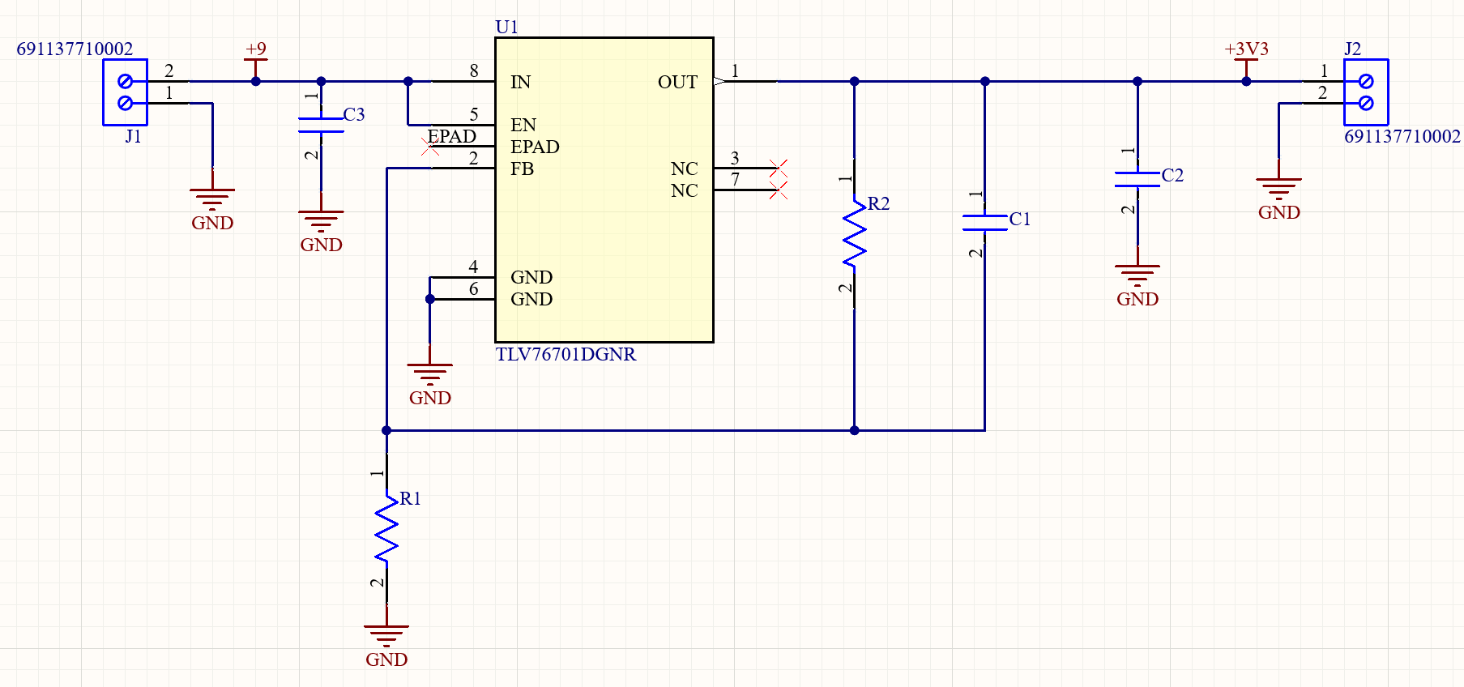

Layout
The layout was designed to handle heat dissipation and maintain signal integrity:
- Power & Ground: Connected using large copper pours to lower trace resistance, support higher currents, and manage thermal dissipation.
- Signal Traces: Routed with standard 0.3 mm trace widths for feedback and enable signals.
